**Exercise 6 – Logging Error Messages and Warning Levels**

**Objective:**

To demonstrate how to log error and warning messages using the **SLF4J logging API** with the **Logback** implementation.

**Steps Followed:**

1. Updated the pom.xml to include dependencies for:
   * SLF4J API
   * Logback Classic (implementation)
2. Created a class LoggingExample.java that logs:
   * One error message
   * One warning message
3. Created logback.xml to configure how logs are printed
4. Ran the main method and verified log output in console

**pom.xml Dependencies:**

<dependencies>

<!-- SLF4J API -->

<dependency>

<groupId>org.slf4j</groupId>

<artifactId>slf4j-api</artifactId>

<version>1.7.30</version>

</dependency>

<!-- Logback Classic -->

<dependency>

<groupId>ch.qos.logback</groupId>

<artifactId>logback-classic</artifactId>

<version>1.2.3</version>

</dependency>

</dependencies>

**✅ Java Code:**

**LoggingExample.java**

import org.slf4j.Logger;

import org.slf4j.LoggerFactory;

public class LoggingExample {

private static final Logger logger = LoggerFactory.getLogger(LoggingExample.class);

public static void main(String[] args) {

logger.error("This is an error message");

logger.warn("This is a warning message");

}

}

**Logging Configuration:**

**logback.xml (place inside src/main/resources)**

<?xml version="1.0" encoding="UTF-8"?>

<configuration>

<appender name="STDOUT" class="ch.qos.logback.core.ConsoleAppender">

<encoder>

<pattern>%d{HH:mm:ss.SSS} [%thread] %-5level %logger{36} - %msg%n</pattern>

</encoder>

</appender>

<root level="debug">

<appender-ref ref="STDOUT" />

</root>

</configuration>

**✅ Output Screenshot:**

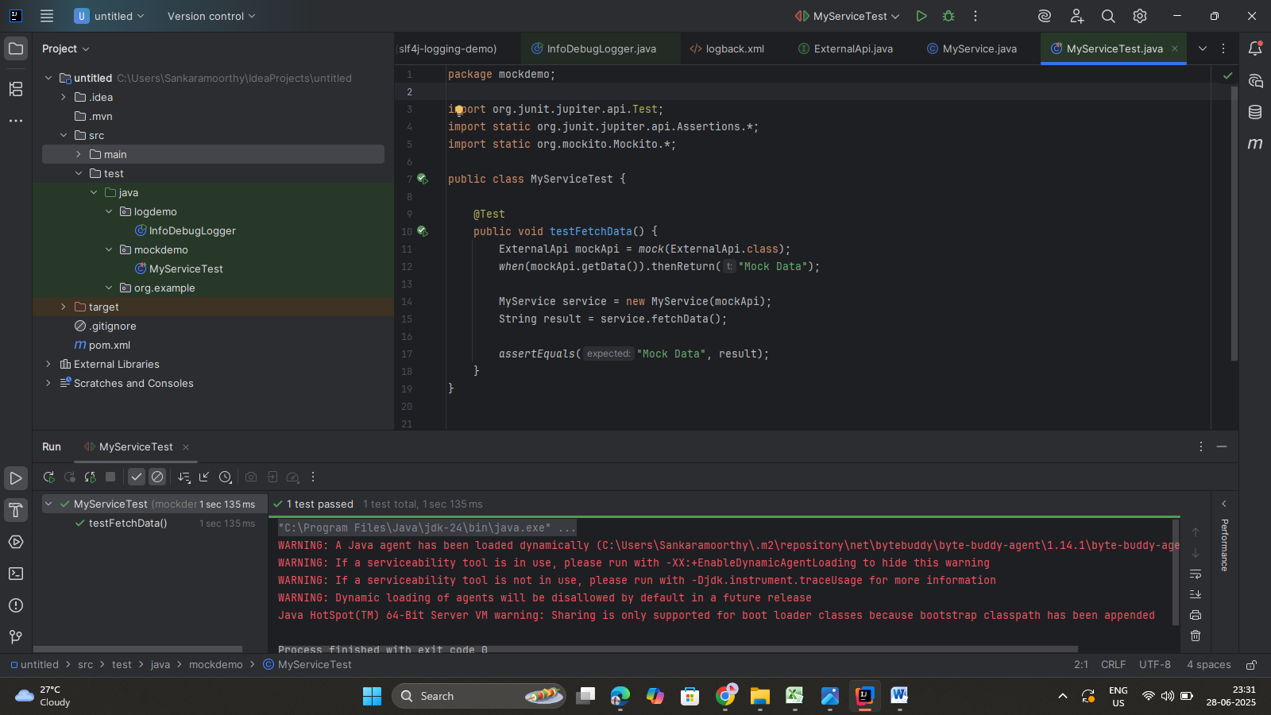

**Tools Used:**

* IntelliJ IDEA
* SLF4J API
* Logback Classic